OBJECTIVE QUESTIONS

Question 1: What is the total no. of attributes present in the data?

Solution:

Final Answer (if any):
16.
First sheet “Ticket” = 10 and Second sheet “IT Agents” = 6

Approach (if any):

Explored the provided data to find number of tables it has

Charts & Tables (if any):
NA

Question 2: Which columns have inconsistent or missing values, and what is the count of such values?

Solution:

Final Answer (if any):
0

Approach (if any):
- After applying filters on all columns, no blank or missing values were
identified in the dataset. Therefore, the count of missing values across all
columns is zero.
- Upon reviewing the dataset, no inconsistent values were found within any
column. Although certain labels may not follow standard terminology they
are used consistently throughout the dataset.
- In the severity status it should be ‘major’ instead of ‘mayor’, ‘Unclassified’
instead of ‘Unclasified’, ‘Unassigned’ instead of ‘Unassiged’.
- Therefore, these are considered labelling or naming conventions not data
Inconsistencies.
Charts & Tables (if any):
NA

Question 3: What is the average daily ticket volume over time?

Solution:

Final Answer (if any):
53.365

Approach (if any):

Created a Pivot Table with the Date in rows and the count of tickets in values to see
how many tickets came in each day.
Looked at the daily ticket counts from the Pivot Table to understand the overall
volume.
Used the =Average() function on the ticket count column to find the average daily
ticket volume.

Charts & Tables (if any):

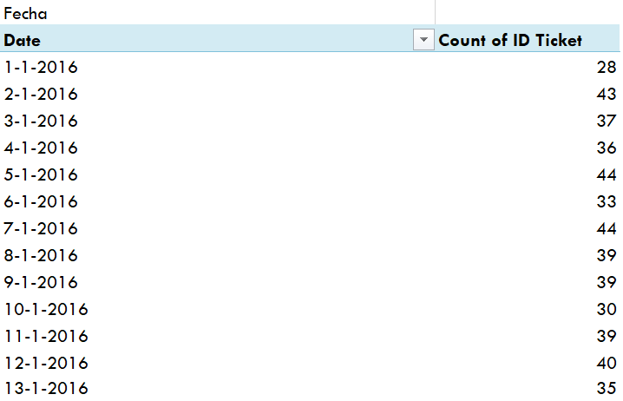

Question 4: What is the distribution of ticket categories (e.g., Login Access, System, Software)?

Solution:

Final Answer (if any):
NA

Approach (if any):
Created a Pivot Table with the Ticket Category column in the Rows field and the
count of tickets in the Values field to see how many tickets belong to each category.
This helped quickly summarize the distribution across categories like Hardware,
Login Access, System, Software.

Charts & Tables (if any):

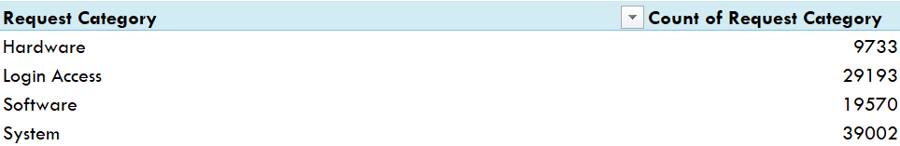

Question 5: How many tickets has each agent handled?

Solution:

Final Answer (if any):
NA

Approach (if any):

Used a Pivot Table with the Agent ID in the Rows field and ticket count in the Values
field to see how many tickets each agent managed.
This gave a neat summary of each agent’s total ticket workload.

Charts & Tables (if any):

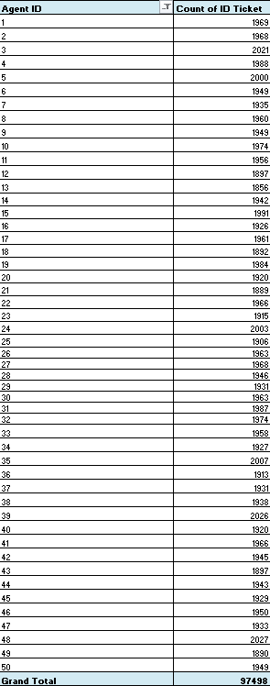

Question 6: How can you extract the domain from the email addresses in the IT Agents sheet?

Solution:

Final Answer (if any):
NA

Approach (if any):

Formula used :
= MID(C2,FIND("@",C2)+1,LEN(C2)-FIND("@",C2)-4) for extracting the domain name from the email address.

Charts & Tables (if any):

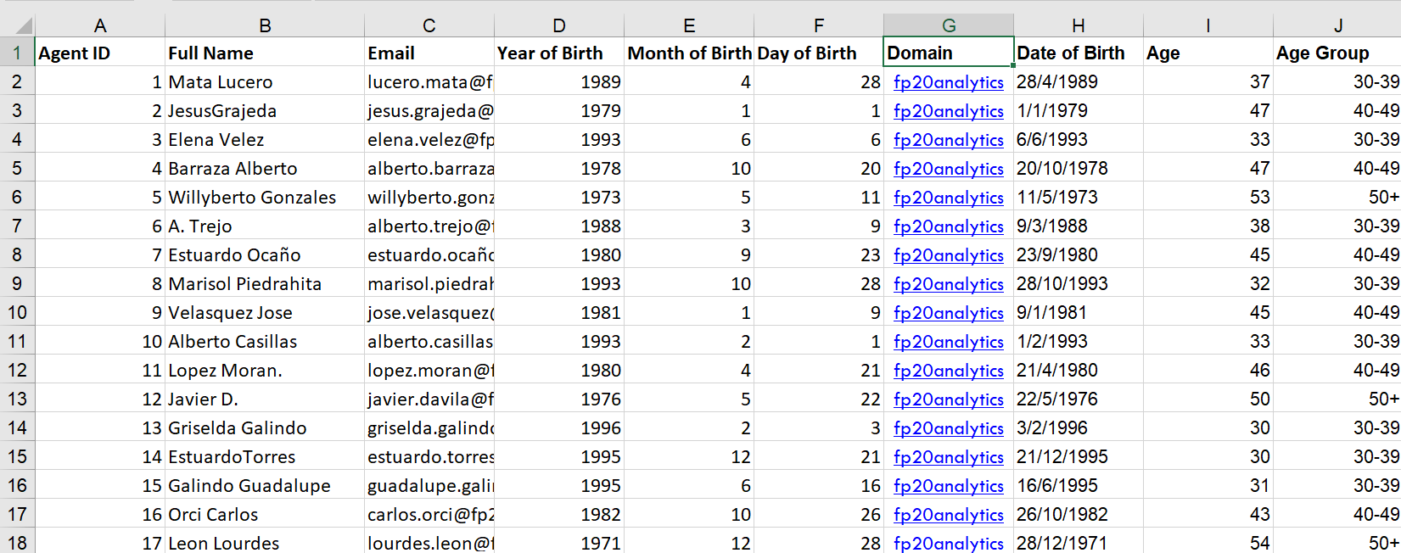

Question 7: How can you find the full name of an agent given their Agent ID?

Solution:

Final Answer (if any):
NA
Approach (if any):

I used the VLOOKUP function to find the Agent ID in the IT Agents sheet.
Then, I used VLOOKUP to get the agent's Full Name from the matching row.
I used the formula {=VLOOKUP(G2:G97499,'IT Agents'!$A$1:$G$51,2,0)} to automatically find and fill in the agent names.
This made the process faster and reduced the need to enter the names manually.

Charts & Tables (if any):

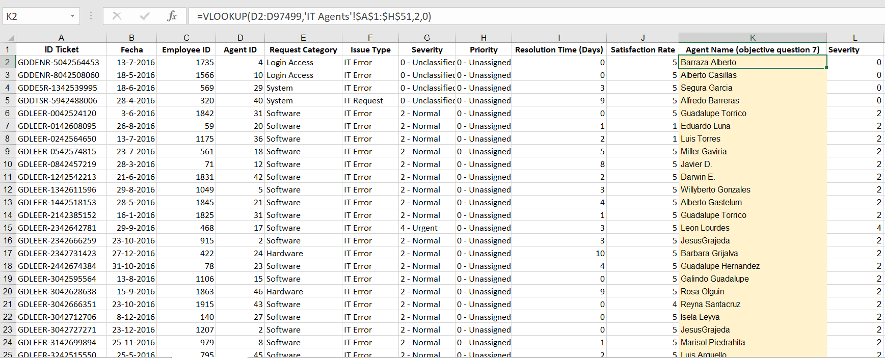

Question 8: What is the count of each issue type (e.g., IT Error, IT Request)?

Solution:

Final Answer (if any):
NA

Approach (if any):

Applied a filter on the Issue Type column to view each category separately.
Selected the filtered cells, and Excel showed the count at the status bar.

Charts & Tables (if any):

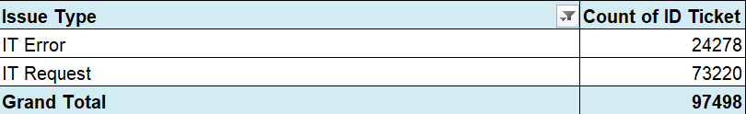

Question 9: What is the average resolution time for tickets?

Solution:

Final Answer (if any):
NA

Approach (if any):
- Selected the entire "Resolution Time (Days)" column to include all values.
- Looked at the status bar at the bottom of Excel, which automatically displays the
average of selected numeric values.

Charts & Tables (if any):

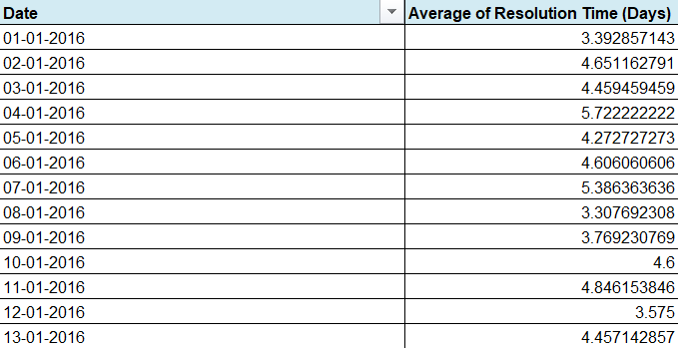

Question 10: How has the volume of tickets changed over time?

Solution:

Final Answer (if any):
NA

Approach (if any):

Created a Pivot Table with the Date in the Rows section and Ticket ID in the
values section, using Count to calculate the number of tickets. Grouped the dates
by Month and Year to make the information easier to understand. Created a Line
chart from the Pivot Table to clearly see how the number of tickets
changed over time.

Charts & Tables (if any):

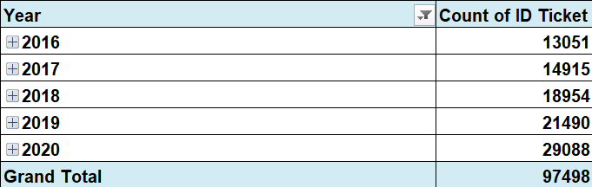

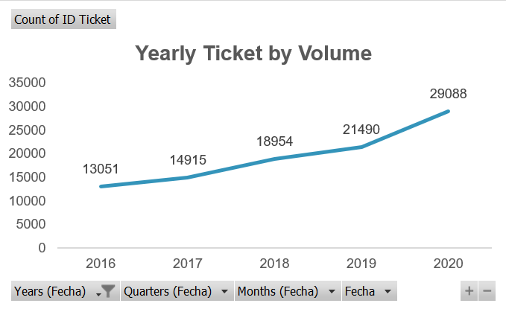

Question 11: What is the average age of the IT agents?

Solution:

Final Answer (if any):

The Date of Birth was given in separate Year, Month, and Day columns. I combined these columns to create a complete date using the CONCATENATE function.
Then, I used the DATEDIF formula to calculate the age of each agent based on their date of birth and the current date.
Finally, I used the AVERAGE function on the Age column to calculate the average age of all agents.
The average age of the agents is 41.08 years.

FORMULA USED:
=CONCATENATE(F2,"/",E2,"/",D2)
=DATEDIF(H2,TODAY(),"y")

Approach (if any):
Created a valid full birthdate helped in accurately calculating each agent’s age.
The DATEDIF function gave the current age for each agent based on today’s date.

Charts & Tables (if any):
NA

Question 12: Is there a correlation between the severity of issues and the resolution time?

Solution:

Final Answer (if any):

The correlation coefficient between issue severity and resolution time is -0.0405.
This indicates a very weak negative relationship between the two variables.

Approach (if any):
= CORREL('Cleaned Data'!L:L,'Cleaned Data'!I:I)

Charts & Tables (if any):
NA

Question 13: How many categorical columns are there in the data? [Search about categorical and continuous data, and try to answer this question]

Solution:

Final Answer (if any):
9
First sheet “Tickets” = 6 and Second sheet “IT Agents” = 3

Approach (if any):

Explored the dataset to find out how many columns contain categorical data.

Charts & Tables (if any):

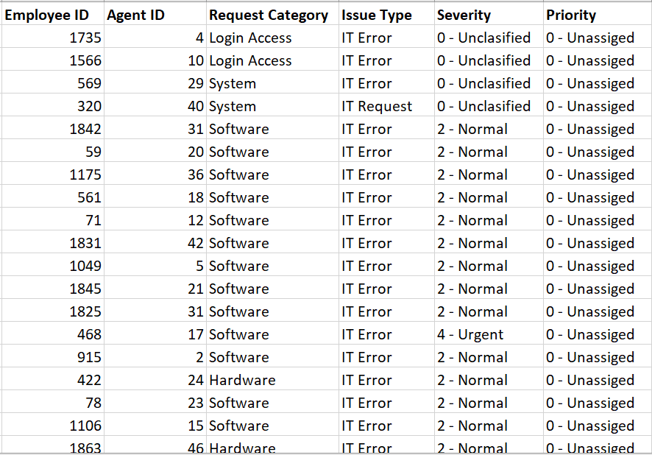

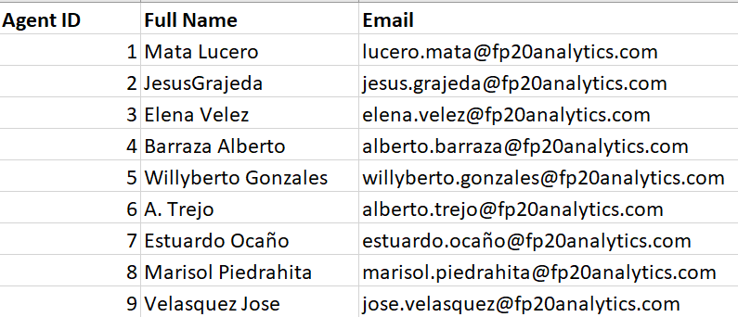

SUBJECTIVE QUESTIONS

Question 1: If there is an investment, should it be used to hire more IT agents, improve training programs, or upgrade ticket management software?

Analysis: Perform a cost-benefit analysis using ticket resolution and satisfaction metrics.

Solution:

Approach:

Cost Benefit Analysis: Cost benefit analysis is a systematic process for evaluating
the potential costs and benefits of a project, policy or decision to determine if the
advantages outweigh the expenses.

The following metrics from the dataset are used:
- Average Ticket Resolution Time (Days) – operational efficiency
- Customer Satisfaction Score (Out of 5) – service quality
- Total Tickets and Agents – workload intensity
- Ticket Distribution by Category, Severity, Priority and Issue Type – operational complexity

Cost Benefit Analysis:

Option 1: Hire Additional Agents

COST | BENEFIT | RESULT
10 agents × ₹6,00,000 = ₹60,00,000 | -Approx 10% reduction in dissatisfaction = ₹15,00,000  -Marginal reduction in dissatisfaction | High recurring cost with limited long-term efficiency improvement.

Insights:
- Adding 10 agents increases workforce by 20% which can reduce workload per agent.
- Estimated 10% reduction in dissatisfaction but no major process improvement.
- Improvement depends heavily on manual effort not system efficiency.
- High recurring cost (salary every year).

Limitations:
- Does not solve root causes like priority handling or repeat tickets.
- Difficult to scale sustainably.

Option 2: Improve Training Programs

COST | BENEFIT | RESULT
50 agents × ₹20,000 = ₹10,00,000 | -5% reduction in repeat tickets = ₹24,00,000  -Better handling of tickets across severity and priority levels | -Satisfaction expected to improve from 4.1 to 4.3  -Better utilisation of existing workforce.

Insights:
- Training cost is relatively low compared to hiring.
- Reduces repeat tickets by 5% indicating better resolution.
- Improves agent confidence and standardization of responses.
- Moderate impact on employee satisfaction.

Limitations:
- Benefits depend on how well agents apply training.
- Does not significantly reduce resolution time without system support.

Option 3: Upgrade Ticket Management Software

COST | BENEFIT | RESULT
Software + implementation = ₹25,00,000 | -Productivity gain equivalent to 17 agents  -Cost avoided = 17 × ₹6,00,000 = ₹1,02,00,000  -Reduced dissatisfaction benefit = ₹36,50,000  -Total benefit = ₹1,38,50,000 | -Smart routing by category, severity, priority  -Faster handling of urgent and major tickets

Insights:
- One time investment with very high return.
- Smart routing by category, severity and priority directly addresses operational inefficiencies.
- Productivity gain equivalent to 17 agents without hiring.
- Faster handling of urgent and major tickets which strongly impacts satisfaction.

Limitations:
- High initial investment
- Agents need time to adapt to new system.
- System downtime or technical issues can disrupt operations.

Recommendation:
- Based on the cost benefit analysis, the initial investment should be made on improving training programs.
- While upgrading ticket management software provides high efficiency gains, improving training programs delivers a balanced combination of cost efficiency, workforce development and employee satisfaction making it the most appropriate investment choice at this stage.
- In the short term, training programs deliver cost effective improvements in employee satisfaction and service quality. However, in the long term, upgrading ticket management software becomes essential to sustain efficiency, scalability and high employee satisfaction as operational complexity increases.

Question 2: Which agents need additional training based on their performance metrics?

Analysis: Identify agents with the lowest satisfaction ratings and longest resolution times.

Solution:

Approach:
To identify agents who require additional training, an agent wise pivot table
was created using Agent ID as the row field. Two performance metrics were
considered:
- Average Resolution Time (Days)
- Average Satisfaction Rate

Charts & Tables:

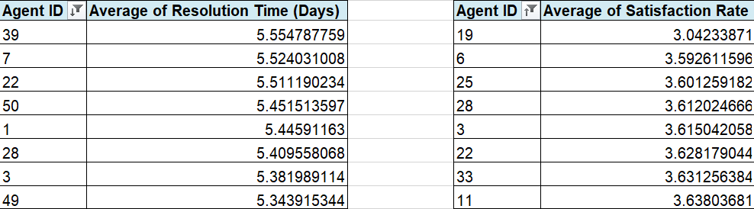

Insights:
The overall average resolution time (4.55 days) and overall average
satisfaction rating (4.10) were used as benchmarks. Agents showing higher
than average resolution time along with lower than average satisfaction
ratings were flagged for further review.

Agents with highest average resolution time (in days):
- Agent 39
- Agent 7
- Agent 22
- Agent 50
- Agent 1
- Agent 28
- Agent 3
- Agent 49

Agents with lowest average satisfaction rate:
- Agent 19
- Agent 6
- Agent 25
- Agent 28
- Agent 3
- Agent 22
- Agent 33
- Agent 11

The analysis shows that these agents are likely facing challenges related to ticket handling efficiency, technical clarity or customer communication which is directly impacting customer experience.

Recommendations:
It is recommended that the identified agents undergo targeted training
programs focusing on:
- Faster and structured ticket resolution techniques
- Technical refresher sessions for complex issues
- Customer communication and soft skill improvement

Question 3: Do certain categories of requests have longer resolution times?

Analysis: Analyse the resolution times by request category.

Solution:

Approach:
Analyse the resolution times by request category.

Charts & Tables:

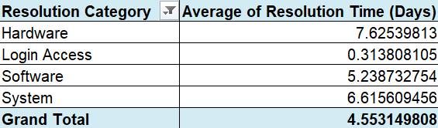

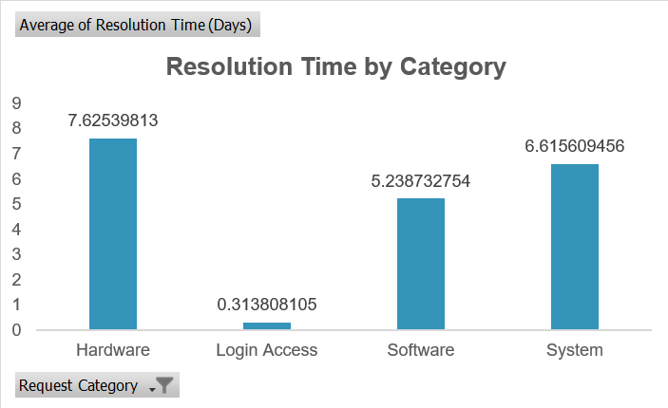

Insights:
- Hardware problems take the longest to solve. On average, hardware-related tickets take about 8 days to resolve.

Recommendations:
- Keep users informed: Tell users that hardware problems may take more time to fix and provide regular updates about the progress.
- Create a fast-track process: For urgent hardware problems, create a special priority process to solve them faster and reduce delays in work.

Question 4: How effective are the current software tools in managing IT tickets?

Analysis: Evaluate performance metrics before and after the implementation of new tools.

Solution:
Approach:
To evaluate the effectiveness of the current software tools used for IT ticket management performance was analysed using pivot tables in Excel.
Since the dataset does not explicitly mention the timeline of new tool
implementation, effectiveness was assessed through operational indicators
such as ticket volume handling, resolution efficiency, customer satisfaction, severity–
priority alignment and year wise performance trends.

Charts & Tables:

1. Ticket Volume & Resolution Efficiency

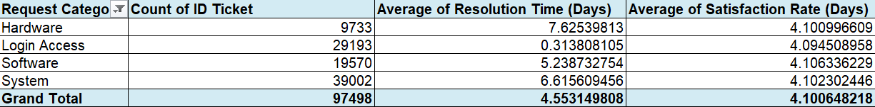

Insights:
- Urgent problems are solved quickly when they have high or medium priority, but they take longer when the priority is low.
- Major problems are not always handled quickly, especially when they are given low priority.
- Normal problems are very common, but they may not always get enough attention.
- Tickets without a priority level take a moderate amount of time to solve. Better sorting and assigning of tickets could make the process faster.

2. Severity vs Priority Analysis

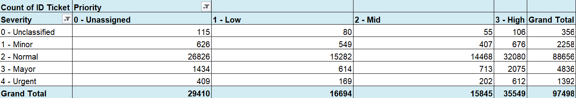

Insights:
- The severity-priority pivot table highlights misalignment in ticket classification:
- A significant number of Urgent and Major severity tickets are assigned Low or Unassigned priorities.
- For example, out of 1392 urgent tickets only 612 are marked as high priority.
- Such mismatches indicate limitations in rule based prioritization or manual dependency rather than resolution capability.
- This suggests that while the tool resolves tickets effectively priority assignment logic needs optimization.

3. Year wise Trend Analysis (2016-2020)

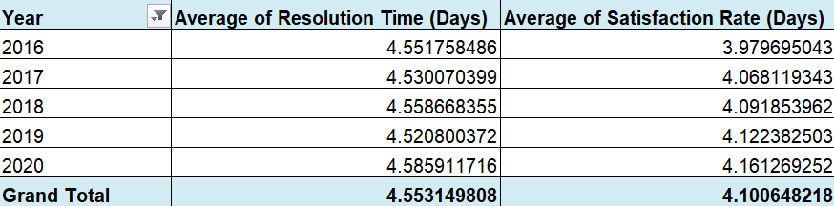

Insights:
- Average resolution time remains stable around 4.5 days across years.
- Customer satisfaction shows a gradual improvement rising from 3.97 in 2016 to 4.16 in 2020.
- This indicates consistent system performance and improving user experience over time driven by operational maturity rather than major tool changes.

Data Limitation Statement
The dataset does not explicitly specify the timeline or indicators for the
implementation of new software tools. Therefore, a direct before and after
comparison is not feasible.

Recommendations:

- The current software tools are moderately effective in managing IT tickets.
- They demonstrate strong scalability, consistent resolution times and positive customer satisfaction. However, effectiveness is constrained by priority–severity misalignment which can delay critical issue resolution.
- Rather than replacing the tools, improvements should focus on:
- Enhancing automated severity based priority rules
- Improving escalation workflows for urgent tickets
- Reducing manual dependency in ticket classification
- Overall, the tools support efficient ticket management but targeted process and configuration improvements are required to achieve higher operational effectiveness.

Question 5: How has the performance of the IT support team changed over time (e.g., monthly or quarterly)?

Analysis: Trend analysis using time series charts.

Solution:

Approach:
To understand how the IT support team’s performance has changed over time I
carried out a year wise and month wise trend analysis using Excel. Created a line
chart to compare how both metrics behaved over time.

Key Metrics:
- Average Resolution Time (in days)
- Average Satisfaction Rate

Charts & Tables:

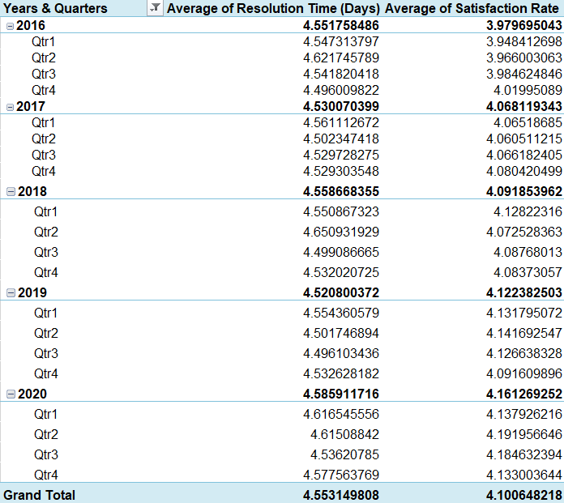

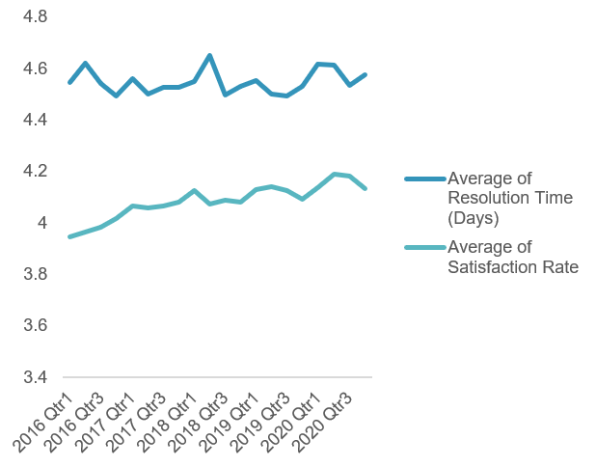

Insights:
Based on the analysis of the data from 2016 to 2020, the following insights were
observed:
- The average resolution time remains relatively stable generally ranging between 4.4 to 4.9 days indicating consistent ticket handling efficiency.
- A slight increase in resolution time is noticeable during certain periods which may be linked to higher ticket volume or complex issues.
- The average satisfaction rate shows a gradual improvement over time moving closer to the 4.1–4.2 range in later years.
- In periods where resolution time slightly increased, the satisfaction rate either stabilized or improved marginally suggesting that quality of resolution may have compensated for delays.
- Overall, the IT support team shows steady and controlled performance rather than sharp fluctuations indicating operational stability
- This trend suggests that the support team has maintained consistent service levels while gradually improving customer satisfaction

Recommendations:
- Based on the observed trends, the following recommendations can be made:
- Continue monitoring resolution time closely during peak workload months to prevent service delays.
- Identify periods with higher resolution time and evaluate staffing or process improvements.
- Since satisfaction rates are improving, best practices used during high-satisfaction periods should be standardized.
- Use historical performance trends to forecast future support requirements and improve planning.
- Regular trend analysis should be maintained to ensure long-term service quality and efficiency.

Question 6: If we invest more on tech (Hardware, software, etc), do you think it will improve the ticket resolution times and employee satisfaction?

Analysis: Use historical data to project potential improvements.

Solution:

Approach:
To evaluate whether increased investment in technology could improve ticket
resolution time and employee satisfaction I used historical performance data as a
proxy.

The analysis compares:
- Category-wise ticket volume
- Category-wise average resolution time
- Category-wise satisfaction score
- Year-wise growth in ticket volume

Categories showing faster resolution and higher satisfaction are assumed to be
supported by better tools, automation or systems. These patterns are then used to
project the potential impact of increased technology investment.

Charts & Tables:

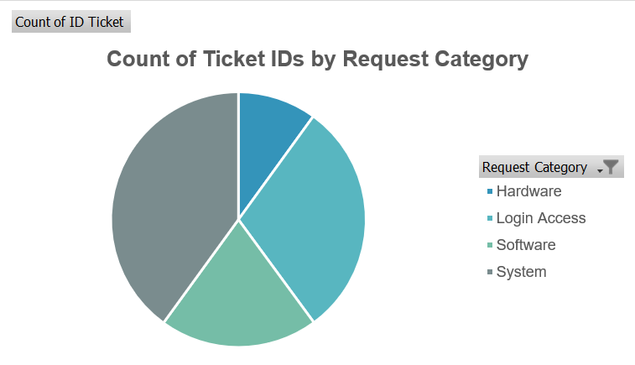

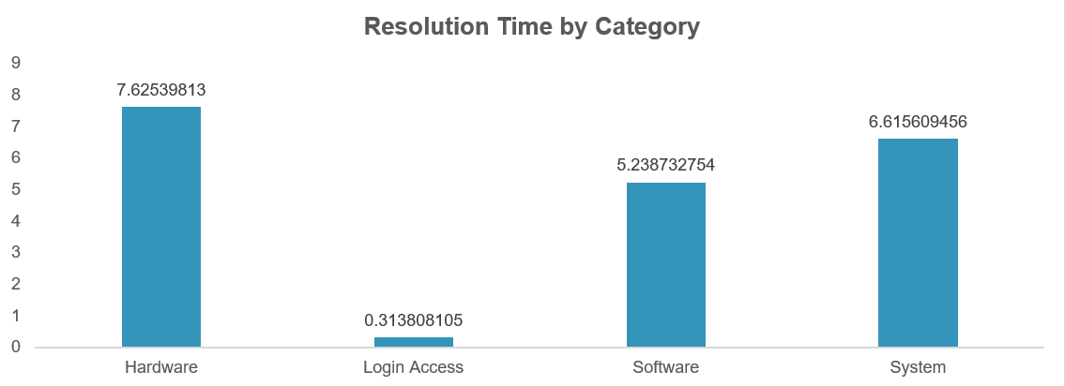
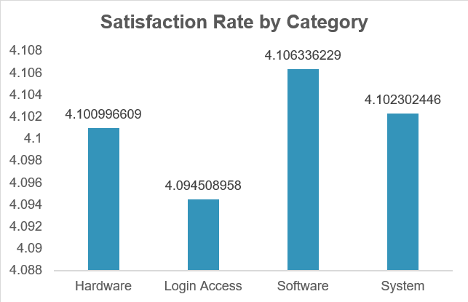

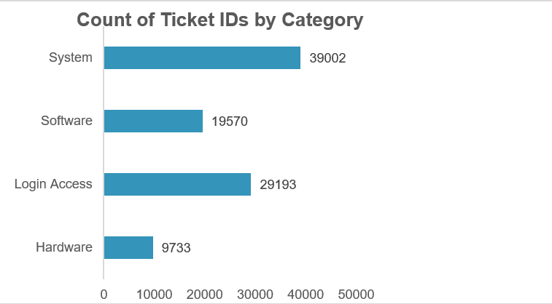

Insights:
From the historical data analysis, the following insights were observed:
- Login Access tickets are resolved extremely quickly suggesting strong automation and efficient tools.
- Hardware and System tickets take significantly longer likely due to manual processes, legacy infrastructure or limited diagnostic tools.
- Despite longer resolution times, satisfaction remains relatively stable indicating users may accept delays for complex issues but this may not scale well as ticket volume grows.
- The consistent rise in ticket volume over the years implies that existing systems will face increasing pressure if not upgraded.

Recommendations:
Based on the analysis and projections:
- Investment should be prioritized toward hardware diagnostics, system monitoring tools and software automation as these categories show the highest resolution delays.
- Expanding automation similar to Login Access workflows can significantly reduce resolution time for repetitive system and software issues.
- Upgrading ticket management software with better categorization, routing and escalation logic can improve efficiency without increasing headcount.
- Overall, targeted technology investment is likely to reduce resolution time and sustain satisfaction levels especially as ticket volumes continue to grow.

Question 7: What are the key performance metrics for IT agents, and how can they be improved, do we need to fire any agents?

Analysis: Define and analyse metrics such as average handling time, satisfaction scores, and number of tickets resolved.

Solution:

Approach:
To evaluate IT agent performance I focused on measurable, objective metrics that
directly reflect both efficiency and service quality.
The following metrics were used:
- Average Handling / Resolution Time – to measure efficiency
- Average Satisfaction Score – to measure service quality
- Number of Tickets Resolved – to measure workload handling and productivity

Key Performance Metrics :
1. Average Resolution Time: Indicates how quickly an agent resolves tickets.
- Higher values may point to:
- Skill gaps
- Complex ticket handling
- Tool or process inefficiencies
2. Satisfaction Score: Reflects end user experience and communication quality
- Low scores may result from:
- Delayed responses
- Poor issue explanation
- Incomplete resolutions
3. Number of Tickets Resolved: Measures workload handling capacity
- Very low counts may indicate:
- Inefficiency
- Over dependence on escalation

Charts & Tables:

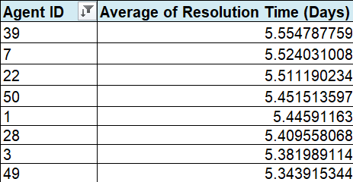

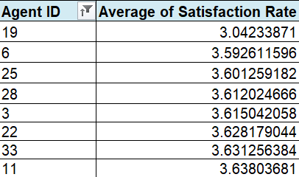

Insights:
- Some agents show higher resolution times along with comparatively lower satisfaction scores indicating scope for improvement.
- Some agents demonstrate efficient resolution times with high satisfaction scores. These agents can be treated as benchmarks for training and process improvement.

Do We Need to Fire Any Agents?
No, firing is not recommended based on this data.
Reasons:
- No agent shows extremely poor performance across all metrics.
- Most underperforming cases show skill or process gaps not negligence.
- Many agents with high resolution times still maintain good satisfaction indicating effort and quality.
When Firing Might Be Considered:
- Metrics are consistently and significantly below team averages and agreed upon standards even after training and coaching.
- If the agent shows no sustained improvement despite receiving targeted training

Recommendations:

For Agents with High Resolution Time:
- Advanced technical training
- Better diagnostic and automation tools
- Knowledge sharing from top performing agents

For Agents with Low Satisfaction:
- Communication and customer handling training
- Clear resolution explanations
- Standard response frameworks

Overall Improvements:
- Match complex tickets with experienced agents
- Set performance benchmarks instead of penalties
- Track improvement through monthly dashboards

Question 8: How do employee demographics (e.g., department, seniority) impact satisfaction and ticket outcomes?

Analysis: Segment analysis using filters and pivot tables.

Solution:

Approach:
The analysis was conducted using pivot tables to segment data by age group and seniority. Key performance indicators such as average satisfaction rate and average resolution time and request category were compared across these segments to understand how demographics and departments influence ticket outcomes.

Charts & Tables:

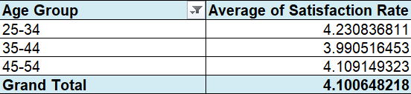

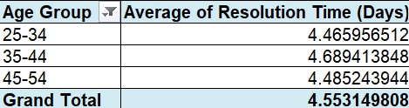

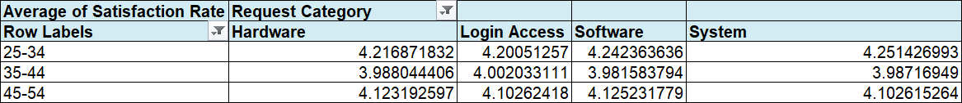

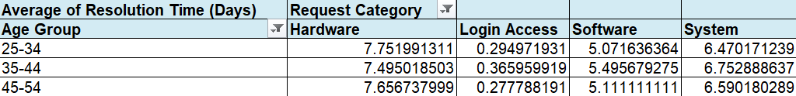

Insights:
Age Group Analysis:
- Agents in the 25–34 age group have the highest average satisfaction rate (≈ 4.23) and a relatively lower resolution time (≈ 4.47 days).
- The 35–44 age group shows the lowest satisfaction rate (≈ 3.99), even though their resolution time is comparable.
- Agents aged 45–54 have satisfaction levels close to the overall average but their resolution time is slightly higher than younger users.
- This indicates that mid-career agents (35–44) may have higher expectations which impacts satisfaction levels.
Request Category (Department) Analysis:
- Login Access requests have the lowest resolution time (≈ 0.31 days) and a high satisfaction rate indicating efficient handling.
- Hardware requests take the longest to resolve (≈ 7.63 days) though satisfaction remains reasonably high.
- System related issues also have higher resolution times (≈ 6.62 days) reflecting their complexity.
- Software issues fall near the overall average for both satisfaction and resolution time.

Recommendations:
- Support strategies should be tailored based on user demographics and issue type.
- Priority handling and clearer communication should be provided for complex categories like hardware and system issues to manage expectations.
- Additionally, targeted feedback mechanisms for the 35–44 age group could help identify specific concerns and improve satisfaction levels.

Question 9: Identify the trends for IT support operations based on ticket volumes and satisfaction, and mention the peak and stable times?

Analysis: Use pivot tables and charts to identify peak and off-peak hours.

Solution:

Approach:
To identify trends in IT support operations, pivot tables were created using
year-wise ticket data. Two key analyses were performed:
- Ticket Volume Trend Over Time – Using a pivot table showing the count of tickets per year per month visualized through a line chart.
- Satisfaction Trend Over Time – Using a pivot table showing the average satisfaction rate per year per month visualized through a line chart.

Charts & Tables:

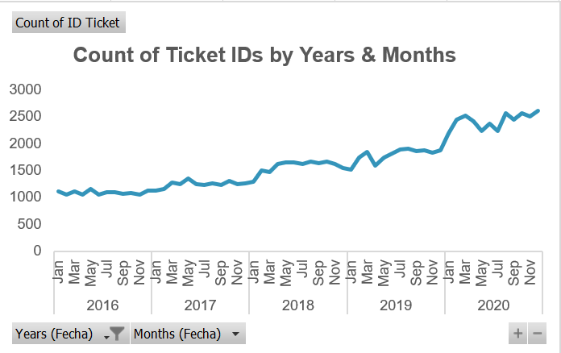
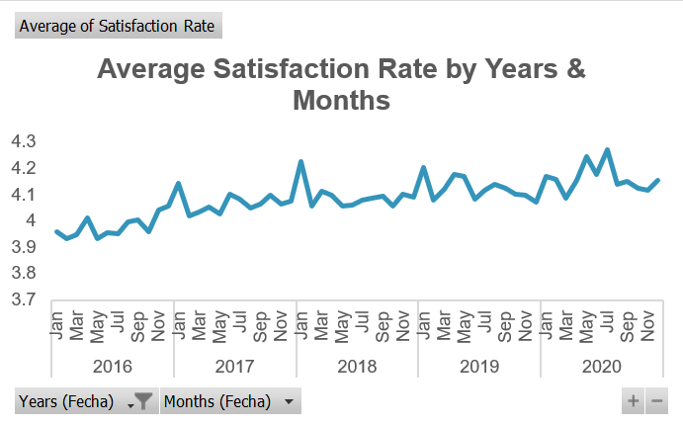

Insights:
- Ticket Volume Trend:
- Ticket volumes show a consistent increase from 2016 to 2020.
- The highest ticket volume is observed in 2020 indicating peak operational demand.
- The lowest ticket volume appears in 2016 representing an early or stable phase of operations.
- The steady upward trend suggests growing dependency on IT support services over the years.

- Satisfaction Rate Trend:
- Satisfaction rate improves gradually from 2016 onwards.
- A noticeable increase is observed after 2017 indicating improvements in service delivery or process efficiency.
- The highest satisfaction levels are seen in 2019–2020 despite higher ticket volumes.
- This indicates that the IT support team managed increased workload without negatively impacting user satisfaction.

Peak and Stable Periods:
Peak period: 2020, as it has the highest ticket volume while maintaining high
satisfaction.
Stable period: 2016–2017, where ticket volumes were lower and satisfaction levels
were relatively steady.

Recommendations:
- Since ticket volumes are increasing every year resource planning and staffing should be scaled accordingly.
- The improvement in satisfaction despite higher ticket volumes suggests that existing processes and tools are effective and should be strengthened further.
- Best practices from 2019–2020 should be documented and standardized to maintain service quality during peak demand.
- For deeper peak and off-peak analysis, future data collection should include ticket creation time (hours) to allow hourly workload optimization.
- NOTE: The dataset does not include time-of-day information. Therefore, peak and off-peak hours could not be analysed. The analysis is based on year-wise trends which still provide meaningful insights into operational growth and performance consistency.

Question 10: What metrics should be included in the final dashboard to provide a comprehensive view of call centre performance and guide investment decisions?

Solution:

Approach:
To design a comprehensive dashboard the focus should be on metrics that capture
workload, efficiency, service quality.
The following metrics are derived from the available ticket, agent, priority, resolution
time and satisfaction data and are visualized using KPIs, pivot tables and charts.
These metrics together help management monitor performance and make informed
decisions regarding process improvement, staffing, training and technology
investments.

Key Metrics to Include in the Dashboard:
1. Ticket Volume Metrics
- Total number of tickets
- Tickets by year / category / priority
Purpose: Helps identify workload trends, peak periods and areas generating the
highest demand.

- Resolution Time Metrics
- Average resolution time
- Resolution time by priority and request category
- Purpose: Highlights efficiency levels and identifies bottlenecks where delays are frequent.

3. Customer Satisfaction Metrics
- Average satisfaction rate
- Satisfaction by year, priority and category
Purpose: Measures service quality and user experience especially under increasing workloads.

4. Agent Performance Metrics
- Tickets handled per agent
- Average resolution time per agent
- Average satisfaction score per agent
- Purpose: Helps identify high performing agents and those who may require additional training or support.

5. Trend & Time Based Metrics
- Year wise ticket volume trend
- Year wise satisfaction trend
Purpose: Supports long term planning and helps evaluate whether performance is
improving over time.

The dashboard should include slicers for choosing the the specific data to make it
more user friendly for management discussions and decisions.

Charts & Tables:

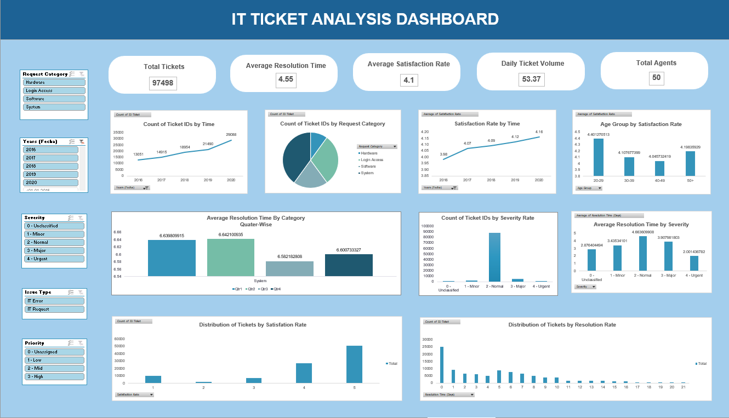

Recommendations: NA

